**Problem 1**

1. Model (m1):
   1. Sets
      * Projects = {1, 2, 3, … , 249}
   2. Parameters
      * **costproject** = the cost of the individual project ∈ Projects (presented in thousands of U.S. dollars).
      * **jobsGeneratedproject** = the number of jobs generated from a given project ∈ Projects (presented in thousands of jobs)
      * **budget** = The U.S. Government’s budget (million USD) to carry out *all* road infrastructure works projects.
   3. Decision Variables
      * **isExecutedproject** = binary variable that indicates if project ∈ Projects is executed by the government.
   4. Objective Function
      * max $\sum_{project ∈ Projects}{{jobsGenerated}_{project}} * {isExecuted}_{project }$
   5. Constraints
 $\sum_{project ∈ Projects}{{cost}_{project}} * {isExecuted}_{project }≤ budget$     * **isExecutedproject** ∈ {0, 1}, ∀project ∈ Projects

**Problem 2**

Please see the “OptiCoffee Analysis Output.xls” file including the output data from the python code. The “Graphs.xlsx file has the associated graphs.

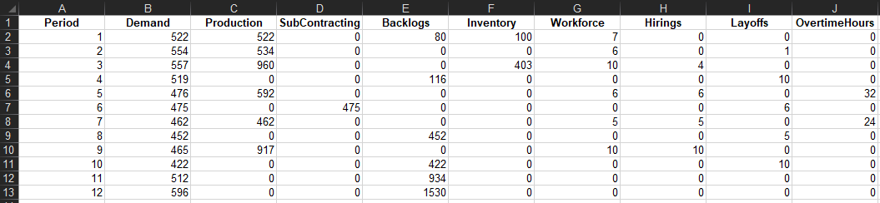

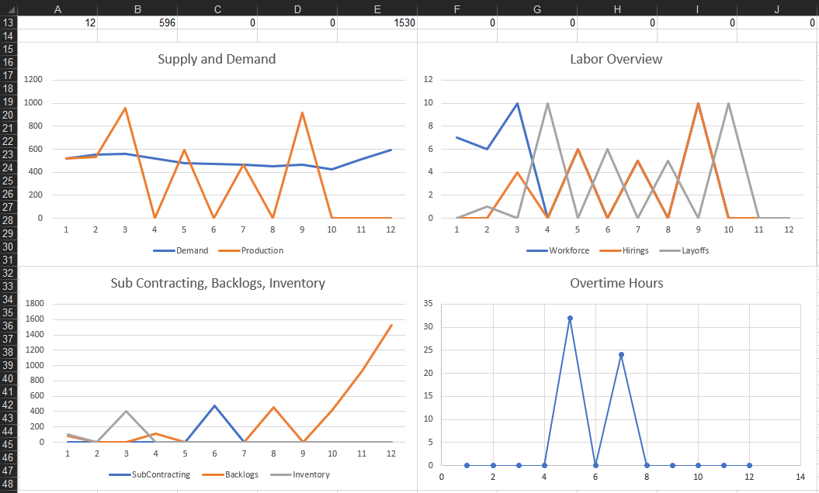

Remarks on Supply and Demand graph and Sub Contracting/Backlogs/Inventory graph:

* Supply may not meet demand in certain periods, but the other three variables make up for production shortages.

Please note that Problem 2(c) would contain the same format above if the code ran properly. Please see the HTML file with an explanation of why the code did not run.